**Lab – 2**

**Rushan Khan Bscs-2**

**To Sir Rafay**

Q:1 Verify following Rules of Boolean Algebra by designing them using Circuit Makers.

**1: Identity Law**

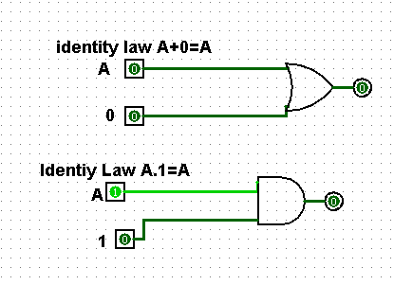

**2: Idempotent Law**

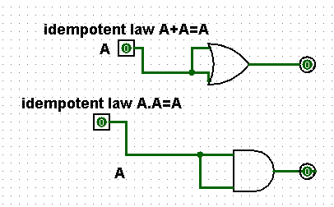

**3: Complement Law**

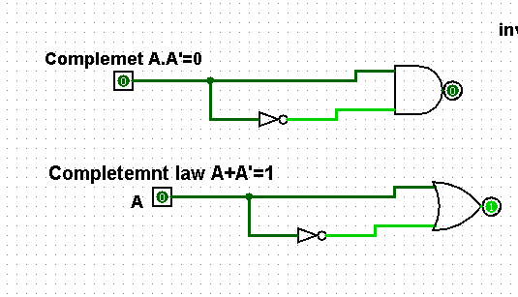

**4: Involution Law**



**5: Commutative Law**

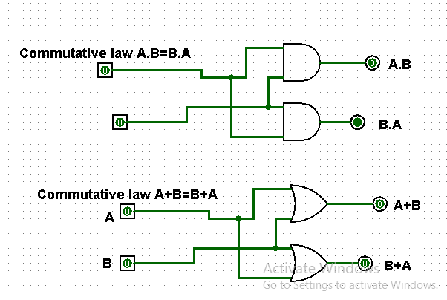

**6: Associative Law**

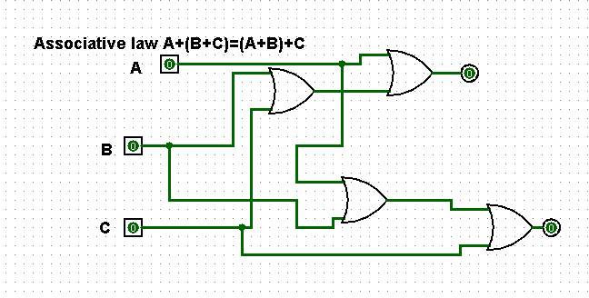

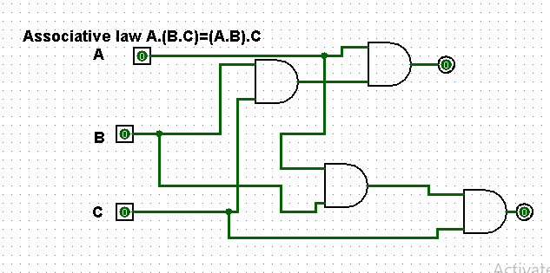

**7: Distributive Law**

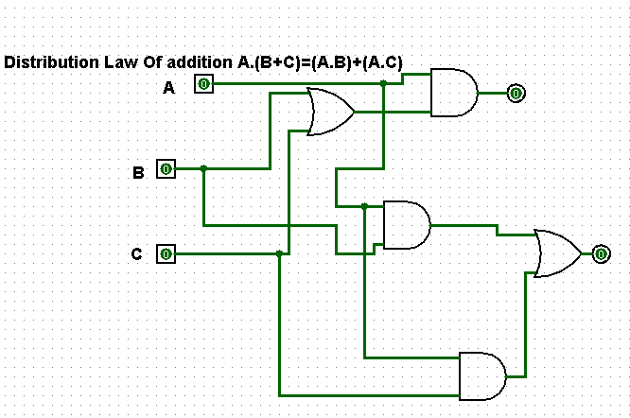

**Q:2 Simplify the expressions**

**1: F = (A + (BC)’)’**

ANS F = [A]’ [(BC)’]’

F = A’BC

**2: F = (AB+CD)’**

ANS F = (AB)’(CD)’

This expression is already simplified.

**Q:3 Use DE Morgan’s Theorem to prove that this NAND gate circuit performs the exact same function:**

**Solve:**

F = [(AB)’ (CD)’]’ BREAKING LONGEST COMPLIMENT

F = [(AB)’]’ + [(CD)’]’ COMPLIMENT LAW

F = AB+CD

**Q:4 Apply the principles of DE Morgan’s theorems to the simplification of a gate circuit:**

**Output:**

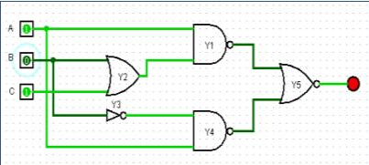

Y1 = [A(B+C)]’

Y2 = B+C

Y3 = B’

Y4 = (AB’)’

Y5 = [ {A(B+C)}’ + (AB’)’ ]’

Solve:

= [ {A (B+C)}’ + (AB’)’ ]’ BREAKING LONGEST COMPLIMENT

= [ {A (B+C)}’ ]’ . [ (AB’)’ ]’ COMPLIMENT LAW

= [A(B+C)] . (AB’) DISTRIBUTIVE LAW

= (AB + AC) . AB’ MULTIPLYING

= (AB’)(AB) + (AB’)(AC) A.A=A , B.B’=0

= A(0) +AB’C

= AB’C

